**Roose Elementary School**



**Home of the Roose Rockets!**

25310 Masch Drive, Warren, MI 48091

Phone: (586) 510-2700 Fax: (586) 510-2709

Ms. Sheila Ann O’Kane, Principal

February 24, 2012

To the Parents of:

Dear Parents,

In our continuing effort to facilitate better communication with parents/guardians, Center Line Public Schools has implemented PowerSchool Parent-Student Portal for students in grades 3, 4, and 5. You now have the ability to securely view your child’s grades, attendance, and other information via the Internet using the PowerSchool Parent-Student Portal.

To access the PowerSchool Parent-Student Portal, you will need the following information:

Log into <https://www.clps.org> under the Parents and Community Link.

There will be a PowerSchool Parent Portal for you to click on.

OR

Direct URL is <https://ps.cen.misd.net/public>

Please be advised that you will be required to complete and sign a Center Line Public Schools Parent-Portal Agreement and provide photo identification to receive your login and password for the PowerSchool Parent-Student Portal.

Please keep your password confidential so only authorized users can access the information. Your user name and password should not be shared with your child. There is parent-specific information that can be altered and should not be available to your child.

Once you have opened the Parent-Portal website, please following the instructions listed below:

Click on Create Account

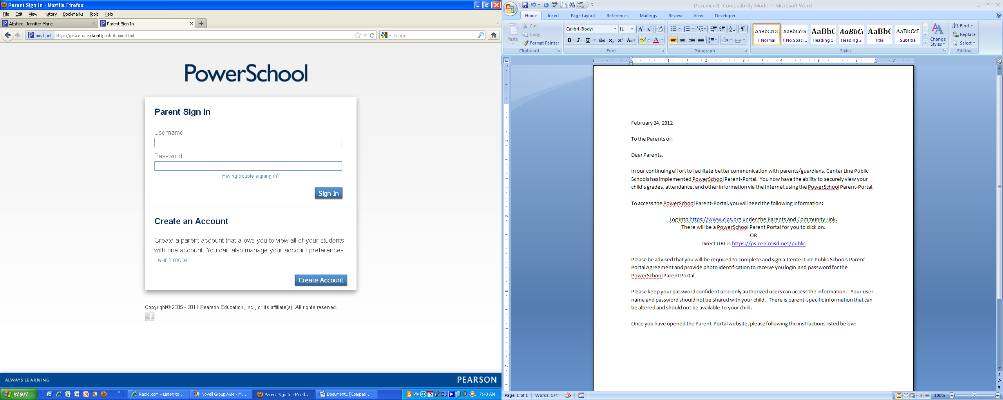

Enter your first name.

Enter your last name.

Enter your email address.

Enter your desired username, this will be your login once your account is created. Please remember that when you log in it will be case sensitive.

Enter your password, reenter your password. Password must be at least 6 characters long.

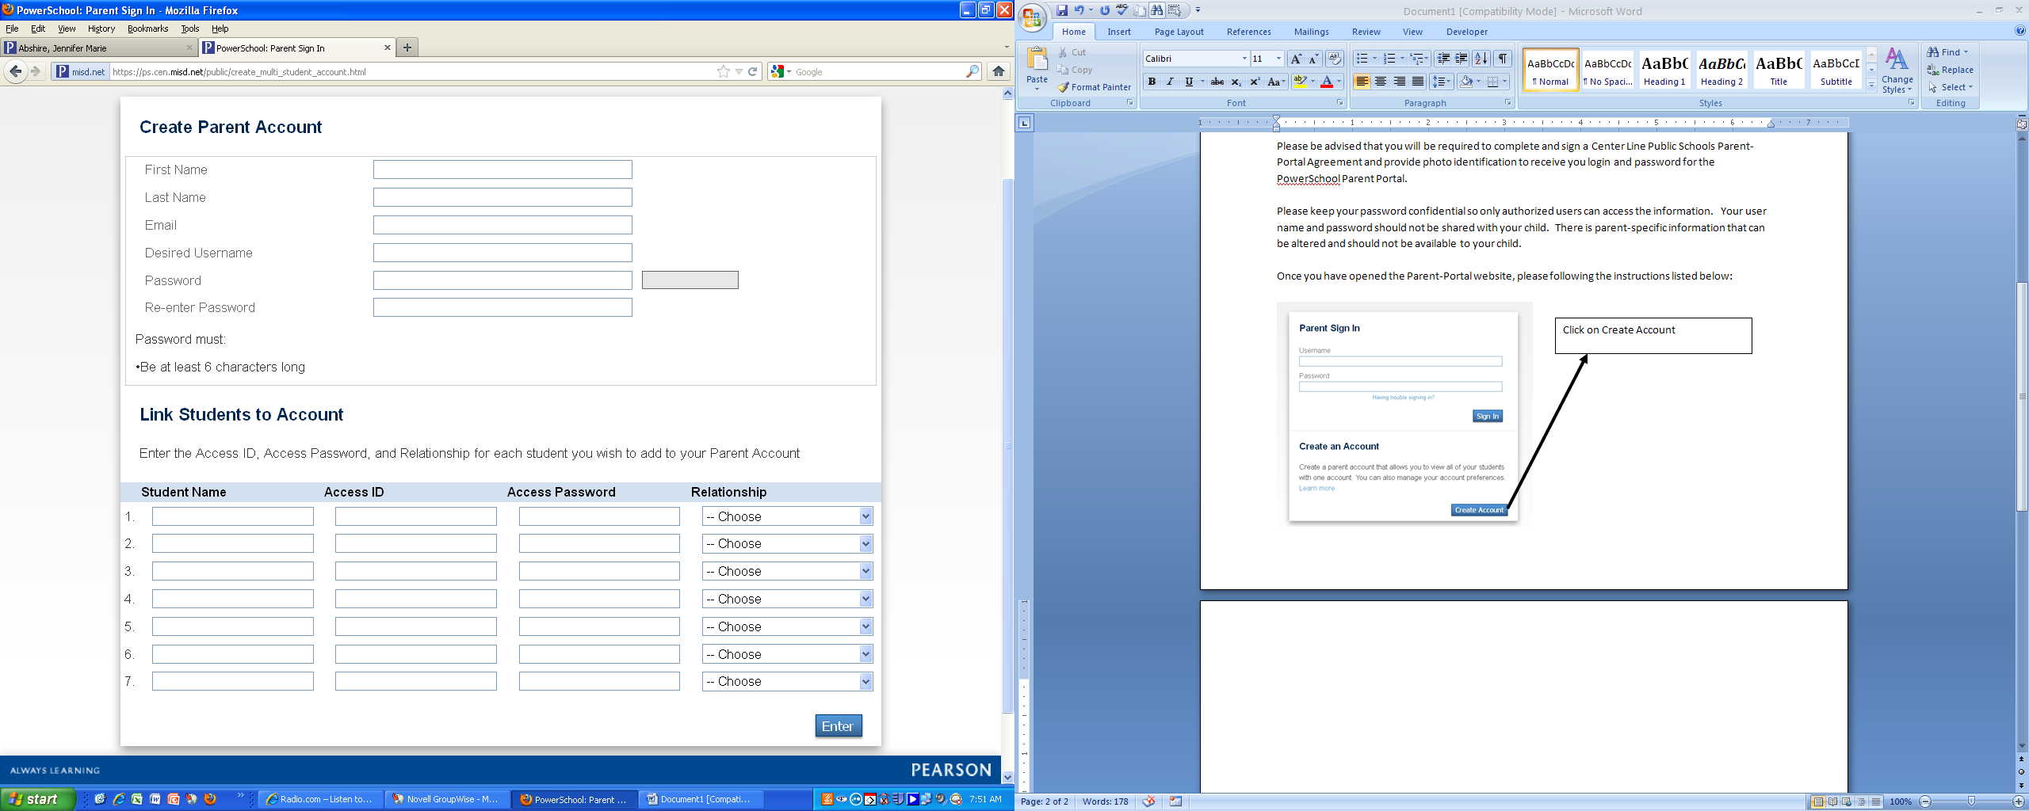

Enter your student’s name.

Enter the Access ID listed below.

Enter the Access Password listed below.

Choose appropriate relationship from drop down provided.

At this point if you have more than one elementary student in grades 3-5 you can add their information. When you log in you will be able to choose the student that you would like to view.

Access ID:

Access Password:

Once you have completed the above steps this screen will appear. Enter the Username and Password that you created in the previous step.

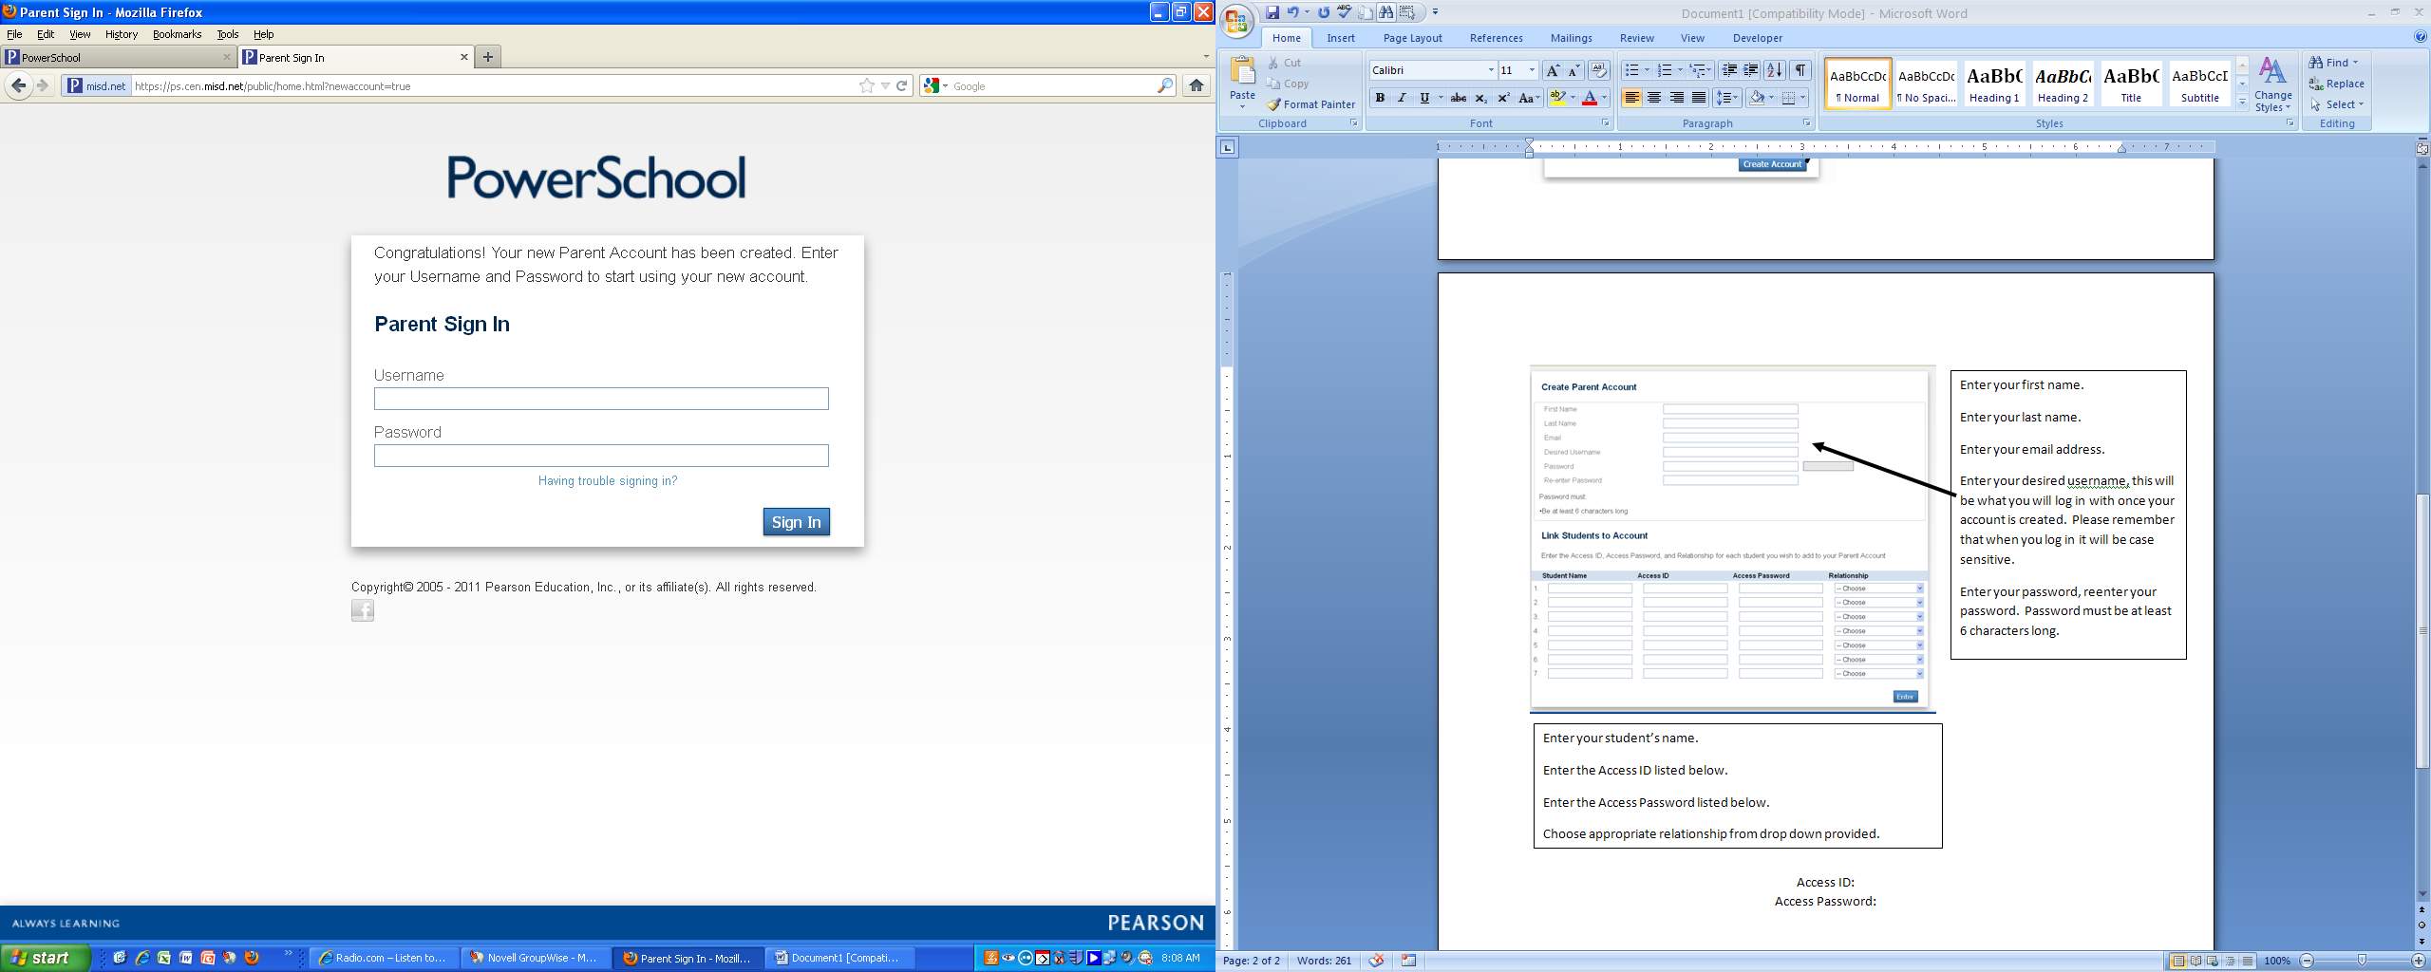

If you have already created an account for one of your children at the middle school or high school, you can just add the elementary student. When you sign into your middle school or high school student’s account, click on Account Preferences and you will see a tab for Students.

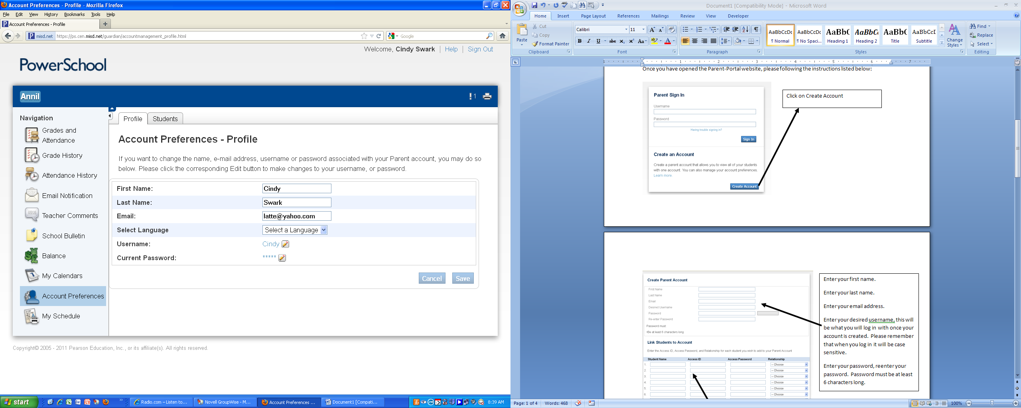

Now your child can also have access to the PowerSchool Parent-Student Portal.

Click on Add+, enter in your student’s information and click on submit. Then at the top of the page under PowerSchool Logo each of your students will be listed.

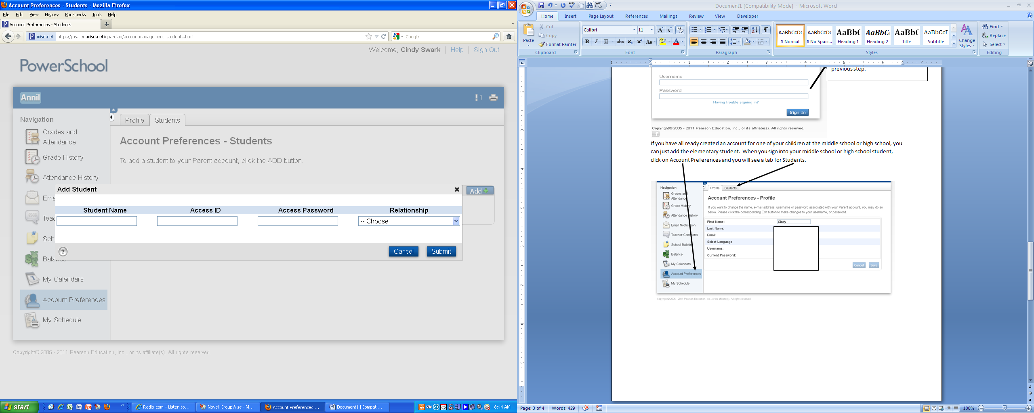

Log into <https://www.clps.org> under the Parents and Community Link.

There will be a PowerSchool Parent Portal for you to click on.

OR

Direct URL is <https://ps.cen.misd.net/public>

When this screen appears your child will enter his/her username and password listed below.



Student’s Username:

Student’s Password:

Please keep in mind that grades will be posted on the PowerSchool Parent-Student Portal by the teachers. Remember that larger projects may require additional time to post. Use the information on the PowerSchool Parent-Student Portal to talk with your child about his/her progress at school.

If you have any issues accessing the PowerSchool Parent-Student Portal, please contact your school office at 586-510-2700.

Sincerely,

Ms. Sheila O’Kane

Principal, Roose Elementary