Assistive

T E C H N O L O G Y

The Macomb County Assistive Technology Guide: Second Edition

m a c o m b i n t e r m e d i a t e s c h o o l d i s t r i c t

updated November 2018

**Welcome**

Welcome to the Macomb Intermediate School District’s (MISD) Assistive Technology Guide: Second Edition. The MISD, its 21 constituent districts and PSA’s have worked cooperatively to provide appropriate educational services to students with special needs for many years. A portion of the Individuals with Disabilities Education Act of 1990 and the reauthorization of this act in 1997 and 2004 requires that assistive technology devices and services be made available to any student with a disability if the Individualized Educational Plan for that student indicates there is an educational need.

This document is a tool to help parents, teachers and administrators understand the process of determining assistive technology needs for special education students. It is our hope that through the use of technology we will be able to improve access to and the quality of educational opportunities for all students within Macomb County.

This Assistive Technology Guide was updated with the help of AT guidelines adopted by the Region IV directors of special education, ensuring continuity and cooperation across the region. Our thanks to all of the members of the Assistive Technology Committee who dedicated their time, knowledge and commitment to produce a meaningful document for providing assistive technology to students with special needs.

We would like to thank Laurel Greenwood and Dr. Kathleen Pistono for their vision in creating the first edition of this guide that served as a model for the provision of assistive technology to students with special needs in Macomb County. Additional thanks extended to the current MISD AT Team, Dr. Maureen Staskowski, Consultant for Speech Language and Literacy and Susan Hardin, Assistive Technology Consultant. Their dedication and leadership resulted in the guide to follow: The Macomb County Assistive Technology Guide: Second Edition.

Beth Alberti

Assistant Superintendent

Special Education and Student Services

Macomb Intermediate School District

Contents

Introduction to AT in Macomb County 5

Mission Statement 5

About the Guide 5

About Assistive Technology 6

The SETT Framework 6

AT Legislation 7

Assistive Technology Provision 7

Assistive Technology Consideration 7

Definition of Assistive Technology Device 7

Definition of Assistive Technology Service 7

MISD’s Assistive Technology Process 8

Universal Design for Learning (UDL) 8

AT Consideration 9

Ongoing AT Consideration 9

AT Consideration: Annual Conversation at IEP 10

When AT Data is Available 10

When AT Data is Not Available 10

Documenting AT Consideration In the IEP: 11

Other IEP Areas where AT is Documented 13

Assistive Technology Trial 14

Determine individual student needs 14

Plan Action 14

Try AT tools 15

Collect and document data 15

Analyze Data 15

Support for Provision of AT Tools and Services 16

AT District Leadership Teams 16

Responsibilities of the District AT Leadership Team: 16

MISD AT Credentials 17

AT District Plans 19

MISD AT Team 19

AT Evaluation 20

Determining the Need for An AT Evaluation 20

Initiating the Evaluation 20

Collaboration with MISD Assistive Technology Team 21

Acquiring AT Devices 21

The MISD AT Lending Library 21

AT Guide Appendix 23

# Introduction to AT in Macomb County

## Mission Statement

* We recognize that assistive technology can eliminate barriers and enable individuals with disabilities to be participating and contributing members of society.
* We believe that all students with disabilities are entitled to receive the assistive technology they need to ensure opportunities for learning.
* We accept responsibility to provide assistive technology services, when appropriate, to assist a child with a disability in the selection, acquisition, or use of an assistive technology device. 1

## About the Guide

The Individuals with Disabilities Education Act of 1990 (IDEA), P.L. 101-476 and the reauthorization of 1997 and 2004, require that assistive technology devices and services be made available to a child with a disability if required as a part of the child’s Individualized Educational Plan (IEP). The Macomb County Assistive Technology Guide has been developed to help Macomb County school districts comply with this legislation.

The Macomb County Assistive Technology Guide: Second Edition was influenced by the 2006, Guidelines for the Provision of Quality Assistive Technology Services: A Plan for Michigan's Region IV. The Region IV plan was developed by representatives from the region’s intermediate school districts (Jackson, Lenawee, Macomb, Monroe, Oakland, St. Clair, Washtenaw, and Wayne).

The Macomb County Assistive Technology Guide: Second Edition outlines the operating principles for each of the Quality Indicators for Assistive Technology. The indicators are a “set of descriptors that could serve as overarching guidelines for quality AT services.” (QIAT 2004).2 The indicators inform the manner in which the shared responsibility for assistive technology is carried out in Macomb County schools.

1 The Region IV Assistive Technology Plan provides a model for the Macomb County Guide. The mission statement is articulated in the Region IV plan and is reaffirmed here by the Macomb County Guide.

2 © The QIAT Consortium (2004). For additional information visit the QIAT website at http://www.qiat.org.

## About Assistive Technology

The term, “Assistive Technology,” encompasses a vast array of devices and services that assist persons with disabilities to participate more fully and successfully in their life roles. In education, assistive technology devices and services are used to help students with disabilities make progress in the curriculum. Assistive technology tools may be needed by students to support communication, mobility, self-care, and other needs arising from sensory, motor, cognitive, language or social impairments.

Assistive technology devices may range from simple modifications like pencil grips to highly sophisticated electronic speech generating devices. Assistive technology services may range from short term instruction, such as teaching a student to use a voice recorder for dictation, to long term and intensive instruction necessary for many augmentative communication interventions.3

Providing appropriate assistive technology is an ongoing process of planning, problem solving, implementation and data review. Applying a systematic approach means that IEP teams are selecting the most appropriate AT tools and providing the best AT services to ensure student success.

Assistive Technology is not an event, but a process that occurs over time. It requires a team approach with a shared vision and shared responsibility for assessment, planning, implementation, data collection and data review. When these tasks are designated and the responsibilities are shared, successful implementation can occur.

## The SETT Framework

Macomb County’s assistive technology assessment process uses the SETT Framework to guide the consideration process. The SETT Framework is an organizational tool used to help collaborative teams create **S**tudent-centered, **E**nvironmentally useful, and **T**ask-focused **T**ool systems that foster the educational success of students with disabilities. The SETT Framework is built on the premise that in order to select appropriate assistive technology devices and services, teams must first gather information about the student, the customary environments in which the student spend his/her time (i.e., the classroom,, lunchroom, playground, home, community setting, or work place) and the tasks that are required for the student to be an active participant in the teaching/learning processes that lead to educational success.

(Joy Zabala, 2002)

# AT Legislation

Below is the legal protection, as it is related to assistive technology, afforded to students with IEP’s by the Individuals with Disabilities Education Act reauthorized in 2004.

## Assistive Technology Provision

Each public agency shall ensure that assistive technology devices or assistive technology services, or both, as those terms are defined in 300.5-300.6, are made available to a child with a disability if required as part of the child’s: (a) special education; (b) related services; or (c) supplementary aids and services. IDEA 2004 300.308

## Assistive Technology Consideration

The IEP Team must consider whether the child needs assistive technology devices and services.

Development of IEP 300.324 (v)

## Definition of Assistive Technology Device

The term “assistive technology device” means any item, piece of equipment, or product system, whether acquired commercially off the shelf, modified, or customized, that is used to increase, maintain, or improve functional capabilities of children with disabilities.

IDEA §300.5

## Definition of Assistive Technology Service

The term “assistive technology service” means any service that directly assists a child with a disability in the selection, acquisition, or use of an assistive technology device. Such term includes –

1. the evaluation of the needs of a child with a disability, including a functional evaluation of the child in the child’s customary environment;
2. purchasing, leasing, or otherwise providing for the acquisition of assistive technology devices by children with disabilities;
3. selecting, designing, fitting, customizing, adapting, applying, maintaining, repairing, or replacing of assistive technology devices; coordinating and using other therapies, interventions, or services with assistive technology devices, such as those associated
4. with existing education and rehabilitation plans and programs;
5. training or technical assistance for a child with a disability or, if appropriate, that child’s family; and
6. training or technical assistance for professionals (including individuals providing education or rehabilitation services),employers, or other individuals who provide services to, employ, or are otherwise substantially involved in the major life functions of children with disabilities.

4 Individuals with Disabilities Education Improvement Act of 2004 [IDEA] § 300.6

# MISD’s Assistive Technology Process

The goal of the AT Process in Macomb County is for all students to have access to and use the assistive technology tools they need to support their progression towards IEP goals and ultimately raise achievement. With that goal in mind this guide begins at the classroom or service provision level, the center of the diagram on the previous page.

Technology is ubiquitous, touching every part of our lives, communities, homes and schools. Across the county, teachers are integrating technology into classroom instruction to promote student engagement, collaboration, feedback, communication and bridge critical thinking. Yet, students who learn differently are still often left behind. Universal Design for Learning is a framework that helps teachers leverage good classroom technology and combine it with intentional curriculum design to give all students an equal opportunity to learn.

## Universal Design for Learning (UDL)

When curricula are designed to include built-in learning supports that address the needs of diverse learners and reduce potential learning barriers, we call that Universal Design for Learning or UDL. The “universal” in UDL does not mean one perfect solution for everyone, but rather an inherently flexible and adaptable curriculum. UDL provides a blueprint for designing instructional goals, methods, materials, and assessments that work for everyone and can be customized and adjusted for individual student needs.

Rose and Meyer (2002)

Universal Design for Learning is at the center of the Macomb AT Model. With its focus on learner variability, flexible technology and designing curriculum to reduce learning barriers, UDL provides a natural bridge for including Assistive Technology devices and services for those students who require it. In UDL classrooms, teachers design instruction with many built in technology supports. Students select and use the technologies that work best for them. This gives students an opportunity to try a variety of supportive technologies and gives teachers a unique opportunity to consider effective AT tool(s) for student success. In this way, AT and UDL work hand-in-hand to support diverse learners.

# AT Consideration

As mandated by the Individuals with Disabilities Education Act 2004, Individual Educational Program (IEP) teams must document the student’s need for assistive technology devices and services annually. Consideration is defined in the Merriam-Webster dictionary as “continuous and careful thought: a matter weighed or taken into account when formulating an opinion or plan.” IEP teams are required to consider and document the outcomes of this careful thought in the student’s IEP.

Quality AT Consideration meets the following indicators:

* Assistive technology is used to support a student’s IEP goals and objectives.
* At least one person on the IEP Team must have adequate knowledge about assistive technology.
* Consideration should be based on progress made in the general curriculum. IEP teams should review the data related to a student’s progress toward their IEP goals and objectives. If insufficient progress is being made, AT should be considered as an option to support goals/objectives.
* Consideration is a data-based decision. Performance data should be reviewed and interpreted in order to make an informed decision about AT needs and outcomes.
* IEP teams should record the deliberation that lead to the decision made. Even if a team decides AT is not necessary, the team must documentation to support the rationale for their decision and the data to support it.

## Ongoing AT Consideration

## * Flowchart of the following information is available in the appendix

Consideration of AT tools and services is ongoing and should occur throughout the IEP year. Consideration may come in many forms. It can occur informally via team discussions, ongoing observation and experimentation or in a more formal meeting such as an IEP or Parent/Teacher conference.

In UDL and technology rich classrooms, AT consideration begins with a conversation about the variety of technology the student is using and the benefit(s) that it provides. To determine the benefit, the team/service provider routinely collects performance data on student’s IEP goals and objectives, with and without the technology. If the progress is the same, then the tool should not be considered assistive technology. If the data indicates that with the technology the student makes additional or faster progress, or if the student progresses more independently toward an IEP goal, then the technology should be considered AT and documented in the student’s IEP.

If a student is not making adequate progress with the current technology/curriculum, the team should analyze student performance data, identify barrier(s) toward progress and determine if additional AT supports are required.

## AT Consideration: Annual Conversation at IEP

* Flowchart of the following information is available in the appendix

### When AT Data is Available

If ongoing AT consideration data or data from an AT trial has been collected prior to the meeting, the team should analyze the data and determine if the data indicates the need for the AT tool.

* If the AT tool is necessary, it should be listed in the IEP in Special Factors. Also, the decision and the data that supports the decision should be included in the Supplemental Aids and Services section of the IEP.
* If the data shows little progress with or without the tool, and the team feels that it has yet to determine whether AT is necessary,
  + the team should select another AT tool and begin an AT trial or
  + If the team is not sure what tool to try, they should consult with the District AT Leadership team, which may lead to the need to complete an AT Evaluation.
* If the team agrees that the data indicate that the AT tool is not necessary at this time, they should document that on the IEP.

### When AT Data is Not Available

If the IEP team has not considered assistive technology prior to the IEP or has no AT implementation data, consideration should occur at the IEP. Some general rules about AT Consideration **when it begins at the IEP** include:

* Assistive technology is used to support a student’s IEP goals and objectives, therefore, AT consideration should occur after the goals and objectives have been developed.
* Consideration at the IEP should be a fairly brief process, one that can take place within the IEP meeting without unduly extending it. It should last at least two minutes, but no more than 15 to 20 minutes. If a decision cannot be reached in a timely fashion, then AT will need to be addressed in another forum such as in an assistive technology evaluation.
* If the student has made minimal progress or his/her progress depends on adults to help with accommodations the following set of guided questions should be addressed.

1. What tasks related to the student’s IEP goals and objectives is the student unable to do at a level that reflects his/her skills/abilities? List the tasks.
2. Could the student complete these tasks with new strategies or accommodations? The team should list the strategies and accommodations that may meet the student’s needs.
3. Would the use of assistive technology tools help the student perform the task more easily, efficiently, effectively or independently in the least restrictive environment? The team should list the assistive technology tools that may meet the student’s needs.
4. Is the student receiving remedial support to learn the skills needed to do these tasks more independently? The team should assure that the student’s IEP includes remediation.

If the team answers yes to question 3, then the team generates potential assistive technology solutions. This may include tools readily available in the classroom as well as tools borrowed from the district/county AT Lending Library. If the team is unable to identify AT tools to try, they should consult with the District AT Leadership team, which may lead to and AT trial or an Assistive Technology Evaluation.

* + - If the team identifies a technology(s) to try, they initiate an AT Trial (See AT Trial Flowchart).
    - If the team is not sure what tool to try, they should consult with the District AT Leadership team, which may lead to the need to complete an AT Evaluation.
* If the students is independent and making progress toward IEP goals and objectives, the team should indicate the AT is not necessary at this time. The team must have data based documentation and record it in the Supplemental Aids and Services section of the IEP to support the rationale for their decision.

## Documenting AT Consideration In the IEP:

Assistive technology devices and services required by a student with a disability should be clearly documented in the student’s IEP. The type of technology that the student requires and the manner in which it will be used should be specified so that all parties to the IEP, including parents, have a clear understanding of the technology and how it will be used.

Once assistive technology has been documented in the IEP, it must be provided in the manner in which it was specified.

In Macomb County assistive technology consideration must always be addressed in the Consideration of Special Factors, Section E of the IEP. Data to support the consideration outcome should be indicated in the Supplementary Aids and Services section of the IEP.

In the PowerSchool Special Ed system, on the Special Factors Page, Section E, IEP teams must select one of the following:

The IEP Team considered whether {name} needs assistive technology devices and services in order to progress toward {name’s} IEP goals and objectives and….

1. AT is necessary. {Name} is using (type of AT Tool) to support (Learning Area)
   1. All tools the student needs in order to progress in his IEP goals and objectives should be documented here.

Note: Program level assistive technology tools, tools that all students use in the classroom, may or may not meet the above criteria. It is up to the team to determine if the student needs any given tool to improve task productivity, independence, quality, quantity or performance to allow progress toward their IEP goals and objectives. One way to determine if the tool is necessary, is to collect and compare performance data with and without the technology.

1. It has not yet been determined whether {Name} needs AT in order to progress toward his IEP goals and objectives. The Team plans to make this decision in the following way:
   1. The IEP Team has agreed to implement and document a trial of AT supports to determine need. (An AT Trial plan will be generated when this item is checked)

Note: If during the consideration process the team identified Assistive Technology tools to trial, this option should be used. Data collected will determine the effectiveness of the tool. The team will then amend the IEP following the AT Trial to indicate the trial’s outcome.

* 1. The IEP Team has agreed to initiate an AT evaluation. (This will require a REED and will trigger a district AT evaluation and AT planning meeting)

Note: If the IEP Team determined they did not have enough information to make an adequate decision about whether assistive technology would support the student’s IEP goals and objectives, this option would be selected.

* 1. Assistive Technology is not necessary at this time.

Note: The team should document the discussion as it occurred in the IEP meeting to justify this decision.

### Other IEP Areas where AT is Documented

Assistive technology can also be addressed in additional sections of the IEP. The need for assistive technology may be addressed in the Present Level of Academic Achievement and Functional Performance, in the listing of special education and related services, and in the annual goals, benchmarks, and objectives. Assistive technology may also be addressed in the supplementary aids and supports section, in the Assessment- Participation and Provisions, and Other Factors.

**Present Level of Academic Achievement and Functional Performance:**

This section provides a natural place to address assistive technology use when it is an integral part of the student’s curriculum. When documenting assistive technology in the present performance levels, the type of technology that is needed as well as the manner in which it will be used should be described.

**Supplemental Aids and Services:**

The outcome of the assistive technology consideration discussion should be documented here.

**Goals and Objectives:**

When developing annual goals, and objectives, the IEP team should determine whether or not the student requires assistive technology in order to accomplish them. First the goals should be developed and then the need for assistive technology should be addressed. Assistive technology is not the goal. Rather, it is the means to achieving the goal for many students.

**Assessment- Participation and Provisions:**

Since the re-authorization of the Individuals with Disabilities Education Act, IEP teams must address the accommodations and modifications that a student requires in order to participate in state-wide and district-wide assessments. For some students with disabilities, assistive technology may be a required accommodation.

When AT is required for assessments, it **must** be noted that the student **must receive** **ample training and practice with the AT accommodation prior to use on the assessment.** AT for assessment and instruction must be integrally intertwined. No AT should be used during an assessment if the student has not had ample opportunity to learn and effectively use the AT during classroom activities.

# Assistive Technology Trial

Consideration is the first step of the AT trial process. When a team determines a need for assistive technology tools and services, the plan-do- check action cycle above is initiated. In Macomb County, we call this an AT Trial. (See appendix for copy of the MISD AT Trial Plan).

* Determine individual student needs
* Plan Action
* Try AT tools
* Collect and document data
* Analyze AT data
* Determine individual student needs (cycle recurs) …

## Determine Individual Student Needs

AT the IEP, when a team identifies that a student is not progressing in their IEP goals/objectives, and it is suspected that assisted technology may be necessary for a student to make progress, the IEP team should begin trying AT tools. The trial begins with a discussion centered on the **student’s** strengths and needs as related to the learning objective.

## Plan Action

Once a **student** need is clearly outlined, the service providers create a “plan of action”. First, they identify any regularly occurring curricular **task(s)** in which the selected goal is addressed. They look for inherent barriers in the task that prohibit student success. These barriers are what the team will mitigate or support with the technology identified. Next they discuss how the **environment** in which these tasks occur may have an impact on an AT tool. Then, they determine which **tool(s)** to trial (See appendix for the AT Consideration Tool Guide). Limiting the trial to one or two tools at a time allows the team to accurately record results and leads to quicker student technology adoption. The plan should include specific information related data collection, student/staff training and classroom implementation strategies. Set a reasonable time for the trial (typically 8 to 12 weeks) to ensure that students have a chance to learn the tool well and develop strategies for using it within the learning environment.

## Try AT tools

Once training has occurred, the AT tools are integrated into curricular tasks as part of regular instruction. Implementation success increases when educators select short, regularly occurring activities to introduce new tools and monitor progress.

## Collect and Document Data

Gathering and recording the outcome data of AT implementation is an essential component of good AT decision making. AT data is used to guide future decisions related to continued use or modification of AT services and tools, and to identify any unmet needs. AT effectiveness is measured by monitoring the impact AT has on the student’s progress toward achieving educational goals.

Based on the area of need, teachers and service providers chart progress related to a student’s increased participation, independence, quantity, quality, speed or accuracy when completing the target task.

Data collection should

* be dynamic and responsive to the student’s performance.
* be on-going. It should last the duration of the trial and be sufficient enough to guide the IEP team in making a decision regarding AT effectiveness.
* occur across environments.
* result in changes to student service plans based on the data collected.

## Analyze Data

The value in data collection occurs when teachers/service providers analyze the data to determine the success of the AT supports and to identify what student needs are still unmet. Based on the data, teachers decide if the tool is necessary, if further trial of the same tool is needed, or if a different tool should be tried. If a further trial is deemed necessary, the AT consideration process begins again. When an AT tool is identified as necessary, it must be documented in the IEP. (See AT in the IEP section of this guide for more details.)

AT Trial Process

# Support for Provision of AT Tools and Services

## AT District Leadership Teams

In order for IEP teams to successfully implement the AT decision making process and to plan for effective AT implementation and review, they receive ongoing support from their district’s Assistive Technology Leadership team. Every local school district in Macomb County has an AT Leadership team. The role of the district team is to support the implementation of AT tools throughout all educational practices in the district. The district AT Leadership Team provides information and training to teachers, parents and students regarding the need to provide ongoing considered, acquisition, implementation and documentation of AT services. AT leaders also play a lead role in the district’s implementation of Universal Design for Learning (UDL) principles.

### Responsibilities of the District AT Leadership Team:

#### District AT Leadership teams provide Leadership:

* Lead and coordinate the district’s assistive technology implementation efforts.
* Meet regularly with director of special education and the technology and curriculum leaders in the district.
* Maintain and update the district’s AT website.
* Act as a resource to the staff in the district regarding AT.
* Provide support to the district in the implementation of Universal Design for Learning in general education.
* Design and implement a process for teachers to request support from the AT Leadership team as written in the district AT plan.
* Support teachers and teams as AT/UDL is implemented throughout the curriculum.
* Discuss student needs and various technologies that may help.
* Observe classrooms/students and make suggestions.
* Assist teachers or others in identifying how technology would be implemented within the curriculum.
* Assist teachers or others in trying various AT devices and technology to support the curriculum.
* Model the implementation of AT with specific curricular activities.
* Inform district staff about the process to borrow equipment from the Macomb ISD’s Assistive Technology Lending Library.
* Lead IEP teams as they complete assistive technology evaluations.
* Coordinate Assistive Technology and UDL training for staff and administration in the district.

#### District AT Leadership teams provide Collaboration and Professional Learning:

* Through networking, gain and share AT information with other districts and the MISD AT team.
* Seek out additional resources as needed to keep up to date on the latest AT news and information.
* Attend the biannual AT Leadership meetings at the MISD.
* Work toward obtaining AT Credentials and Competencies
* Participate on the AT representative list serve.
* Attend AT trainings (webinars or workshops) to continually build skills and remain current on the tools and processes.
* Collaborate with the MISD AT Team.

#### District AT Leadership teams Plan and Analyze District Services:

* Develop and disseminate the District Annual AT Report
* Update the district AT plan annually.
* Keep data regarding the referrals received and the outcomes of the referral process for reporting and planning purposes.
* Complete annual AT data review, including AT Consideration data from PowerSchool Special Ed, AT leadership team referral data and the Quality Indicators for the provision of AT Services.

# MISD AT Credentials

The MISD Assistive Technology (AT) Leader credential program is designed to ensure the effective use of the MISD AT decision-making and implementation process.  AT Leaders are encouraged to work toward receiving their AT Credential and one or more area competency(s). MISD AT Credentials are mastery based, meaning that AT Leaders are expected to demonstrate their ability to apply their AT consideration and implementation knowledge in support of a student(s) in their district. AT Leaders will receive digital badges acknowledging their exemplary AT knowledge and ability to support IEP teams as they work toward identifying and using AT solutions for students.

The MISD Assistive Technology (AT)  Leader credential program is designed to ensure the effective use of the MISD AT decision-making and implementation process so that students with special needs receive the AT services they need to be fully engaged and successful in the general curriculum. ​The MISD Assistive Technology (AT) Team works collaboratively with local district leaders to ensure that every IEP team has access to a knowledgeable individual to support the consideration and implementation of assistive technology services. In Macomb County, these individuals are known as AT Leaders. AT Leaders coordinate assistive technology efforts in their own district, act as an AT resource to colleagues, lead IEP teams through the assistive technology evaluation process, support teachers and teams as AT is implemented throughout the curriculum and help IEP teams evaluate the effectiveness of AT implementation.

## Macomb AT Leader Credential

To complete your AT Leadership Credential**, you must:

* Attend all 4 days of the AT Leadership workshop
* Achieve competency in at least one micro-credentialed area such as Writing, Reading, Communication or Access.
* Complete the AT Leadership competencies below: Foundational, AT Consideration, Implementation and Follow Up and receive an "achieved" status on your portfolio review.

### AT Foundations

Demonstrate knowledge of educational, human, legal and cultural issues related to assistive technology services, including but not limited to, human development, general curriculum, special needs, trans-disciplinary roles and current laws.  
​

### AT Consideration Process

Demonstrate knowledge and effective use of the Macomb ISD consideration, trial and evaluation processes.  
​

### AT Implementation

Demonstrate knowledge of effective AT implementation, including but not limited to, developing a collaborative AT plan that provides for specific curriculum integration, AT training, data collection, and regularly occurring follow up opportunities.

### AT Follow Up

Demonstrates knowledge required to evaluate the effectiveness of AT services, including but not limited to, periodic review of data collected to identify barriers and adjust strategies and tools

## AT District Plans

Each local district AT Leadership Team works collaboratively with their district’s Special Education Administrators to develop and update the local district AT Plan. This plan guides the district in implementing quality AT services to ensure that all students with an IEP receive the technology support they need to make progress in their IEP goals and objectives. Plans include a description of the district’s AT leaders, their roles and responsibilities, the district’s procedures for obtaining support to identify and use AT devices and services, recommendations for documenting AT in the IEP, the district’s plan to provide all staff with quality professional learning opportunities related to AT, the district’s plan to collaborate with other departments to ensure coordinated efforts and a strategy for evaluating the effectiveness of the district’s AT program.

Plans are adjusted annually based on the outcomes of the district’s annual AT evaluation of effectiveness. Each district reviews their AT Consideration data from PowerSchool Special Ed, their AT Leadership Team referral data and the district’s performance on Quality Indicators for the provision of AT Services. The outcome of this district self-assessment is described in the district’s AT Annual Report. AT data review, AT Annual Report writing and district plan revisions are activities supported at the spring AT Leadership team meeting. Based on the district’s AT Report, the District AT Leadership Team works with their Special Education Administration to finalize the revised annual district AT plan. Teams then discuss ways to ensure that their AT Plan is coordinated with the district’s Technology Plan.

## MISD AT Team

Macomb County’s AT efforts are led by the MISD AT Leadership team. This team provides vision, direction, consultation, training, problem solving and access to AT equipment for the local leadership teams.The MISD Assistive Technology team is comprised of consultants specialized in assistive and instructional technology and communication and literacy. The MISD AT Team provides initial training to new District AT Leaders each year. This is a four day training that provides information on the legalities, procedures, processes, and the technology to support students’ AT needs. The MISD AT Team also provides ongoing training to district leaders via the biannual AT Leadership meetings and other AT professional development offerings. AT Leaders are encouraged to attend several additional AT professional development sessions throughout the year. Additional support is provided to district leaders through ongoing communication via the AT list serve, email, and phone as needed.

Once each year, the MISD AT Team facilitates the District AT Leadership Team’s evaluation of the quality of the AT services in their district. The MISD team also supports the teams as they revise their district AT plan for the upcoming year.

**AT Evaluation**

Macomb ISD has established clearly defined processes for all aspects of assistive technology evaluation. Each district is responsible for maintaining an evaluation procedure consistent with the MISD procedure. Evaluation consistency is ensured via ongoing training and collaboration between the MISD AT Team and the network of District AT Leadership Teams. District AT Leadership teams are responsible for keeping all special education personnel in their district well informed regarding these evaluation procedures. Evaluation procedures include such activities as initiating an assessment, planning and conducting an assessment, conducting trials, reporting results, analyzing outcome data, revising AT plans, and initiating reassessments.

## Determining the Need for An AT Evaluation

Possible situations that may call for an AT evaluation include:

* When a parent requests an AT evaluation.
* When an IEP team is unable to identify an appropriate AT support for the student to progress in their IEP goals.
* When an IEP team identifies the need for a formal, coordinated AT plan.

## Initiating the Evaluation

Macomb County’s AT Evaluation process guides an IEP team through decisions about the selection, acquisition, and use of assistive technology devices and services. When an AT evaluation is needed, the student’s IEP works with the District Leadership Team to complete the evaluation process and develop an AT implementation plan. An AT evaluation is different then most other educational evaluations. Because an AT evaluation is an ongoing process, it must be handled through a series of collaborative meetings interspersed with trial periods and data collection. The AT trial is an integral part of the evaluation. The trials are designed to collect data related the effectiveness of the tool/activity selected. This data guides the team The trial developed is very specific to each task that will be supported and includes how the implementation outcomes will be measured. Every team member leaves the meeting knowing their responsibilities toward carrying out the trial plan and the timeline for implementation. At the onset of the evaluation the team designates an AT Follow-up Meeting date and time, when the outcome of the trial data will be reviewed and the plan will be revised as needed.

To begin, the IEP team generates a Review of Existing Evaluation Data (REED). The team completes the document with the current available data, then determines if additional data is required to address the concern. In some very rare instances, the team may determine that sufficient data already exists to indicate that an AT evaluation is not necessary. This data and the resulting conversation must be documented on the REED.

If the student’s IEP team determines an AT evaluation is necessary, the IEP team develops an evaluation plan, including identifying the AT assessments the team will conduct. Then, consent is requested to conduct the evaluation. An AT evaluation is conducted under the auspices of a member of the District AT Leadership Team using the Macomb County AT Evaluation process and documenting the plan in the AT Evaluation Report found in PowerSchool, Special Education.

Please reference the AT Evaluation Flow chart for the entire AT Evaluation and Trial process.

Assistive technology needs are reassessed when changes in the student’s performance, the environments and/or the tasks result in the student’s needs not being met with current devices and/or services. An assistive technology evaluation can be requested by the parent or any other member of the IEP team.

## Collaboration with MISD Assistive Technology Team

Collaboration between the local district AT Leadership Teams and the MISD AT Team is ongoing. Throughout the year, the MISD AT Team consults with local leadership teams and individual AT leaders as needed to problem solve issues that arise as local AT teams facilitate AT in their district. Consultations may include; the provision of AT program services, AT selection, AT professional development and individual student support. The MISD AT team is committed to support student-centered teams as they assess, develop, plan and implement appropriate assistive technology strategies. These contacts with the AT Leaders are regular and informal and can occur through phone calls, electronic communication or in person, as needed.

# Acquiring AT Devices

## The MISD AT Lending Library

Allowing a student to try an assistive technology device for an extended period of time is the best way to determine if the tool effectively supports the student's access to education. The Macomb County Assistive Technology (AT) Lending Library was developed to allow Macomb County teachers and students that opportunity.

The MISD AT Lending Library loans equipment to educators who work in Macomb County ISD’s service area for the purpose of evaluating the effectiveness of an AT device for students who receive special education services or have a federal section “504” plan.

# AT Guide Appenix

# REVIEW of EXISTING EVALUATION DATA and Evaluation Plan (REED)

| Student: | Date Sent/Given to Parent/Guardian: |
| --- | --- |
| UIC: | Attending School: |
| Date of Birth: | Student Primary Language: |
| Grade: | Language in the Home: |
| Annual IEP Due Date: | Re-Evaluation IEP Due Date: |
| Parent/Guardian: | Current Eligibility: |

## Action Proposed

Purpose: Add/Modifications to IEP

Please Explain: In order to determine the best assistive technology tools to support {Student’s} {area of need e.g. writing, communication} needs, the IEP team is requesting a review of existing evaluation data and a subsequent AT evaluation or trial if deemed necessary.

## Participants of Review

Add list of participants

## Review of Existing Information

| **Information** | **Data Source** | **Description of Information** |
| --- | --- | --- |
| Review existing evaluations including current classroom-based, local, or state assessments; and classroom-based observations. | District writing assessments  CBM Writing fluency assessments  AIMS Web data  NWEA data  Words Their Way Assessments  Cloze Reading Comprehension Assessment data |  |
| Review teacher and related service provider(s) observations. | Teacher report  SLP observation  OT report |  |
| Review evaluations and information provided by parents. |  |  |
| Other: |  |  |

## Review of Input from the Parent

Comments from parent regarding this area of focus goes here.

## Additional Data Needed and Evaluation Plan

| On the basis of the above review, the educational needs of the child, and input from the student's parents, identify the additional data needed to determine the following:  Whether the student has or continues to have a disability. Whether the student has or continues to have a disability.  The student's present level of academic performance and related developmental needs. The student's present level of academic performance and related developmental needs.  Whether the student needs or continues to need special education and related services. Whether the student needs or continues to need special education and related services. Whether any additions or modifications to special education and related services are needed to meet IEP goals and participate in general education. Whether any additions or modifications to special education and related services are needed to meet IEP goals and participate in general education. |
| --- |

| ASSESSMENT AREA | DATA AND ASSESSMENTS NEEDED (Note observations if required) |
| --- | --- |
| Achievement Achievement |  |
| Adaptive Skills Adaptive Skills |  |
| Cognitive Ability Cognitive Ability |  |
| Social Emotional Behavior Social Emotional Behavior |  |
| Speech and Language Speech and Language |  |
| Other: Assistive Technology Other: Assistive Technology | Include Observation, the SETT process and any additional AT evaluation information you may need to collect like the: Written Productivity Profile; uPar, Observation data or Communication Matrix/Profile |
| Other Other |  |

# ASSISTIVE TECHNOLOGY EVALUATION REPORT

The assistive technology (AT) staffing process helps IEP teams to design, implement, and reassess these accommodations in an ongoing process. Students with disabilities often require accommodations to instruction, materials, and activities to progress toward their IEP goals and objectives.

**Student:**   **Today’s Date:**

**Birthdate:**   **Grade:**

**School:**   **District:**

## EDUCATIONAL TEAM MEMBERS PRESENT

List of people present at the meeting. This should include all IEP team members

## The SETT Framework

The SETT Framework is a tool for gathering data in order to make effective assistive technology decisions. The SETT Framework considers first, the STUDENT and his goals/objectives, the student’s ENVIRONMENT(S) and the TASKS required for active participation in that environment, and finally, the system of TOOLS required for the student to address the tasks. This information was gathered through interviews with parents and IEP team members, classroom observation, file review and structured interactions with the student.

### STUDENT

#### GOAL

Select and record the student’s IEP goal and objectives that you wish to support with assistive technology.

List the IEP goal that you want to address with AT. (usually only one)

#### OBJECTIVES

List two to three measurable objectives under that goal on the IEP.

#### PROGRESS

Record the student’s progress toward the selected goal and objectives.

Indicate the progress the student has made toward the goal and objectives you are intending to support with AT! Resist the temptation to list progress on other IEP goals.

##### Additional Factors Relating To Student Progress

Record significant information regarding the student’s strengths and needs as they relate to the selected goal and objectives

**Interests:** List things that motivate the student – activities, rewards, people_________

**Social:** Describe the student’s interactions with peers, adults; flexibility; interest in socializing__

**Sensory:** Describe student’s hearing, vision, tactile (auditory) sensitivity, visual perception skill_

**Motor:** Describe the student’s strength, range of motion, muscle tone, balance, coordination (gross and fine).

**Cognitive:** List the student’s current psych scores, grade-level functioning, educational label, attention span

**Language:** _Describe the student’s receptive and expressive language skills including form and function.

**Behavioral:** Describe the student’s response to criticism/directions, frustration tolerance, and reaction to new routines etc.

### ENVIRONMENT

The team identified the following environmental contexts in which the student uses these goals and objectives

Describe the environment(s) in which the student is learning. Include information about that number of students, staff, the physical layout of the environment etc.

### TASKS

List the regularly occurring activities that relate to the targeted goal and objectives. Briefly describe what all students are expected to do as part of each activity. Estimate how often they occur each week.

| ACTIVITY  Descriptive name of activity | DESCRPTION – What are the students expected to do  A brief description of how the activity unfolds. List the critical elements of the activity. Who does what, when and where. | TIMES/WEEK  How often it occurs |
| --- | --- | --- |
|  |  |  |
|  |  |  |
|  |  |  |
|  |  |  |
|  |  |  |
|  |  |  |

### 

### TOOLS

#### Student Assistive Technology History

Record a brief description of previously attempted AT tools (strategies, accommodations, and modifications). Attach student AT history forms or additional sheet if needed.

| ACCOMMODATION  Describe tool/strategy | OUTCOME  How hid it work? Is it still being used? Why or why not? |
| --- | --- |
|  |  |
|  |  |
|  |  |
|  |  |

### Assistive Technology Observation and Testing Data

Record the results of assessments such as the Protocol for Accommodations for Reading, Communication Matrix, Written Productivity Profile, Observation, etc.

| Record the results of assessments such as the Protocol for Accommodations for Reading, Communication Matrix, Written Productivity Profile, Observation, etc. The assessment and the accompanying results should directly relate the goals/objectives for which you are considering Assistive Technology. Identify the name of the tool used to assess the student. Provide the data resulting from the assessment. Also record observation data and existing data from the IEP team (such as work samples or reading comprehension scores). Summarize the findings. |
| --- |

### Conclusion

Use the insert statements to indicate the outcome of the AT Evaluation.  
Remember, the decision made by the IEP team here, must also be reflected on the Consideration of Special Factors e) on the IEP.

| The team's specific recommendations are as follows: (options in the dropdown menu)   * As a result of this evaluation, the IEP team developed an Assistive Technology Trial. Refer to the AT Trial Plan for further details. * As a result of this evaluation, the IEP team determined that Assistive Technology is not necessary at this time. |
| --- |

# AT Evaluation Trial Plan

Design the plan. Select one or two of the activities above to support using assistive technology strategies and tools. Discuss each activity in more detail and record how they are currently implemented. Stop and discuss various ways to support the student in that activity using AT. Develop a strategy for integrating AT into the activity.

**Name (auto fill); School (auto fill): District (auto fill); date (auto fill)**

**Goal(s):** List the IEP goal that you want to address with AT.

**Objective(s):** List two to three measurable objectives under that goal on the IEP

**Name of Tool(s):** List the name of the tool(s) the team plans to trial. It is best practices to name the tool specifically at the trial level.

## AT IMPLEMENTATION STRATEGY #1 (This repeats)

Select one of the educational tasks listed above. Discuss more fully how the activity is currently completed. Now discuss how the task could be modified and a different tool implemented to target improved performance.

In name of activity the student will do what task

(what activity or course e.g. social studies, Community Based Instruction) (do what task related to their objectives e.g. take notes, follow a job sequence)

using which AT tool .

(what tool? e.g. Neo, Electronic Schedule, Go Talk)

### Data Collection Plan

| **What data will be collected to demonstrate a change in student performance?** | **Data Collection Method** | **Frequency of Data Collection** | **Length of Trial** |
| --- | --- | --- | --- |
| Insert Menu | Insert Menu | Insert Menu | Support Statement |
| number of prompts  number of words  score on a rubric  length of sentence  number of errors  accuracy an assessment  frequency of participation  time to complete task  task completion  reduced support  improved accuracy  other | Observational Data  Tally Sheets  Student work  Anecdotal Notes  other | daily  2-3 x week  weekly  other | AT trials typically last 4-8 weeks |

### TRAINING

Consider what training is needed in order to begin implementation.

**List the persons needing training (teachers, student, parents, etc)**

Name Position/Title

**Responsible Team Member(s)** who will coordinate the training?

Check here

Will provide themselves Identify a trainer Schedule the training

**When** indicate when training will occur

### ACQUISITION

| **List the tools that must be acquired** |  | |  |
| --- | --- | --- | --- |
| Name of AT Tools |  |  | |
|  |  |  | |

**Responsible Team Member(s)** who will acquire the device(s)?

Check here

Will borrow from district Will borrow from MISD

**When** indicate when devices will be obtained

## OTHER ACTIONS NEEDED TO BEGIN IMPLEMENTATION

**Action** Describe the specific activities that need to take place in order for the modifications to work. e.g. provide training, receive training, obtain equipment, make overlays, make phone calls, strategies the team developed for introducing to the student/teacher/parent etc.

**Responsible Team Member(s)** indicate which team member(s) is responsible for this action item.

**When**  usually within 2 weeks *

* remember to take into account other action items that need to occur first.

**Repeat here**

## FOLLOW UP:

AT is an ongoing process. If you’re working with the IEP team to make an AT decision, reconvene to discuss the outcomes at the end of the trial. If further trials are warranted, use another AT Trial Plan form to document the plan. When the team determines the necessary AT, an addendum describing the AT tool should be written into the IEP.

### Follow Up Meeting:

Be sure to do this at the end of the meeting while all participants are still at the table. This saves a lot of unnecessary rescheduling/notification tasks. Be prepared to amend the IEP depending in the results of the AT trial.

Date: _________ Time: ________ Location: ______

Give the team time to implement and evaluate the modifications listed. 4-8 weeks in usually adequate.

## Follow-up Meeting Report

Date: Area available to enter date 

### Assistive Technology Trial Data

Record the results of the AT Trial data and it's impact on student IEP goals and objectives.

| Use this space to develop a narrative related to the AT trial and the data the IEP team collected. Be sure to describe the length of the trial, the student’s change in performance related to the AT implementation, the student’s opinion about the device. Upload any data sheets to PowerSchool Special Ed that will help clarify the trial results. |
| --- |

### Assistive Technology Trial Outcome

Indicate the outcome of the AT Trial. Remember, the decision made by the IEP team here, must also be reflected on the Consideration of Special Factors page on the IEP.

| Assistive Technology Trial Outcome |
| --- |
| Assistive Technology is necessary Assistive Technology is necessary. |
| It has not yet been determined whether Sample needs AT in order to progress toward {his,her} IEP and objectives. The Team plans to make this decision in the following way: It has not yet been determined whether Sample needs AT in order to progress toward {.his,her} IEP goals and objectives.       The Team plans to make this decision in the following way: |
| Assistive Technology is not necessary at this time Assistive Technology is not necessary at this time. |

Assistive Technology Data Collection Sheet

Student:

Target Skill:

Data Collected By:

| Date | Assignment | Tool Used (including app(s) used) | Output (# of Words) | Attitude about tool used | Comments | Initials |
| --- | --- | --- | --- | --- | --- | --- |
|  |  |  |  | Smily face rating scale  http://farm3.static.flickr.com/2553/3757564190_6cb213e13a.jpg |  |  |
|  |  |  |  | Smily face rating scale  http://farm3.static.flickr.com/2553/3757564190_6cb213e13a.jpg |  |  |
|  |  |  |  | Smily face rating scale  http://farm3.static.flickr.com/2553/3757564190_6cb213e13a.jpg |  |  |
|  |  |  |  | Smily face rating scale  http://farm3.static.flickr.com/2553/3757564190_6cb213e13a.jpg |  |  |
|  |  |  |  | Smily face rating scale  http://farm3.static.flickr.com/2553/3757564190_6cb213e13a.jpg |  |  |

AAC Data Collection Sheet

Student:

Target Skill:

Data Collected By:

| Date | Activity | Resists | Attends | Direct Prompt  i.e. point | Indirect Prompt  i.e. wait time | Independence | Messages (Symbols/Words/Signs) |
| --- | --- | --- | --- | --- | --- | --- | --- |
|  |  |  |  |  |  |  |  |
|  |  |  |  |  |  |  |  |
|  |  |  |  |  |  |  |  |
|  |  |  |  |  |  |  |  |
|  |  |  |  |  |  |  |  |
|  |  |  |  |  |  |  |  |
|  |  |  |  |  |  |  |  |
|  |  |  |  |  |  |  |  |
|  |  |  |  |  |  |  |  |
|  |  |  |  |  |  |  |  |
|  |  |  |  |  |  |  |  |
|  |  |  |  |  |  |  | Totals |

AAC Data Collection Sheet

Student:

Target Skill:

Data Collected By:

| Date | Activity | Messages (Symbols/Words/Signs) | # Words/ Sentence |
| --- | --- | --- | --- |
|  |  |  |  |
|  |  |  |  |
|  |  |  |  |
|  |  |  |  |
|  |  |  |  |
|  |  |  |  |
|  |  |  |  |
|  |  |  |  |
|  |  |  |  |
|  |  |  |  |
|  |  |  |  |
|  |  |  |  |
|  |  |  |  |
|  |  |  | Totals |

**ONGOING ASSISTIVE TECHNOLOGY CONSIDERATION**

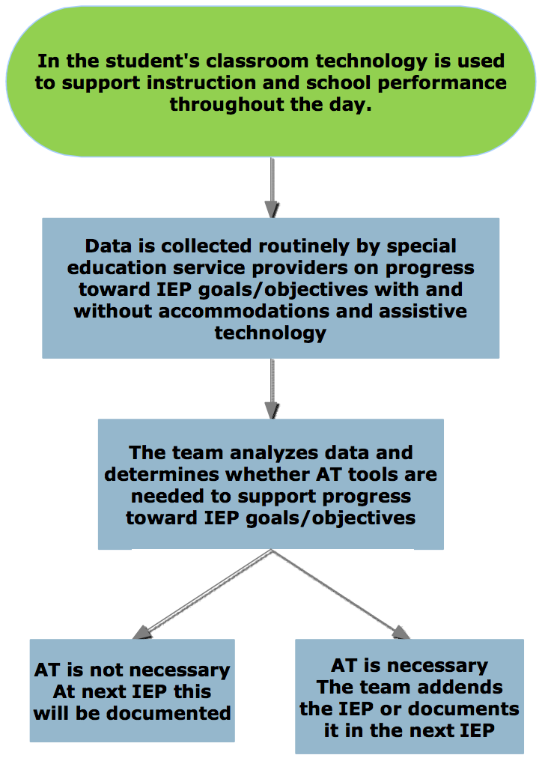

**AT CONSIDERATION: ANNUAL CONVERSATION at IEP**

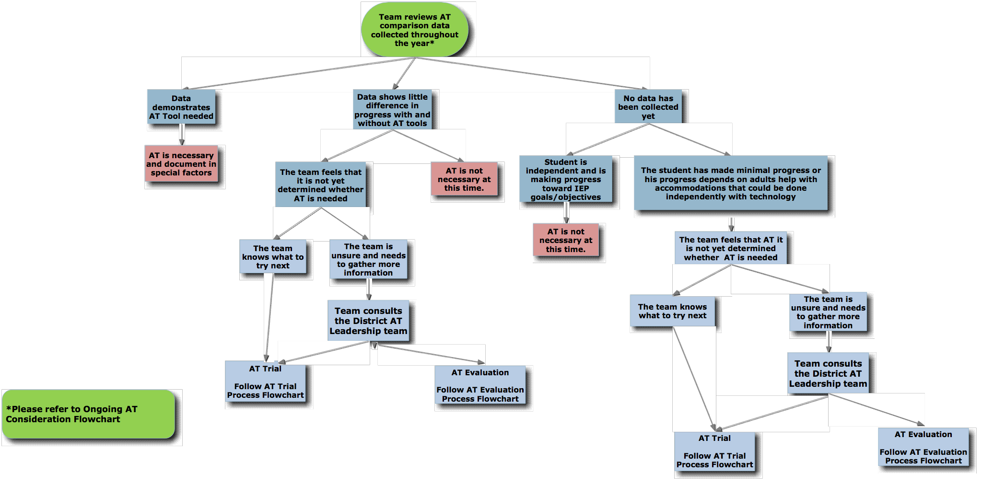

**Assistive Technology Trial Process**

Graphic representation of previous information found on page 16.

**Assistive Technology Evaluation**

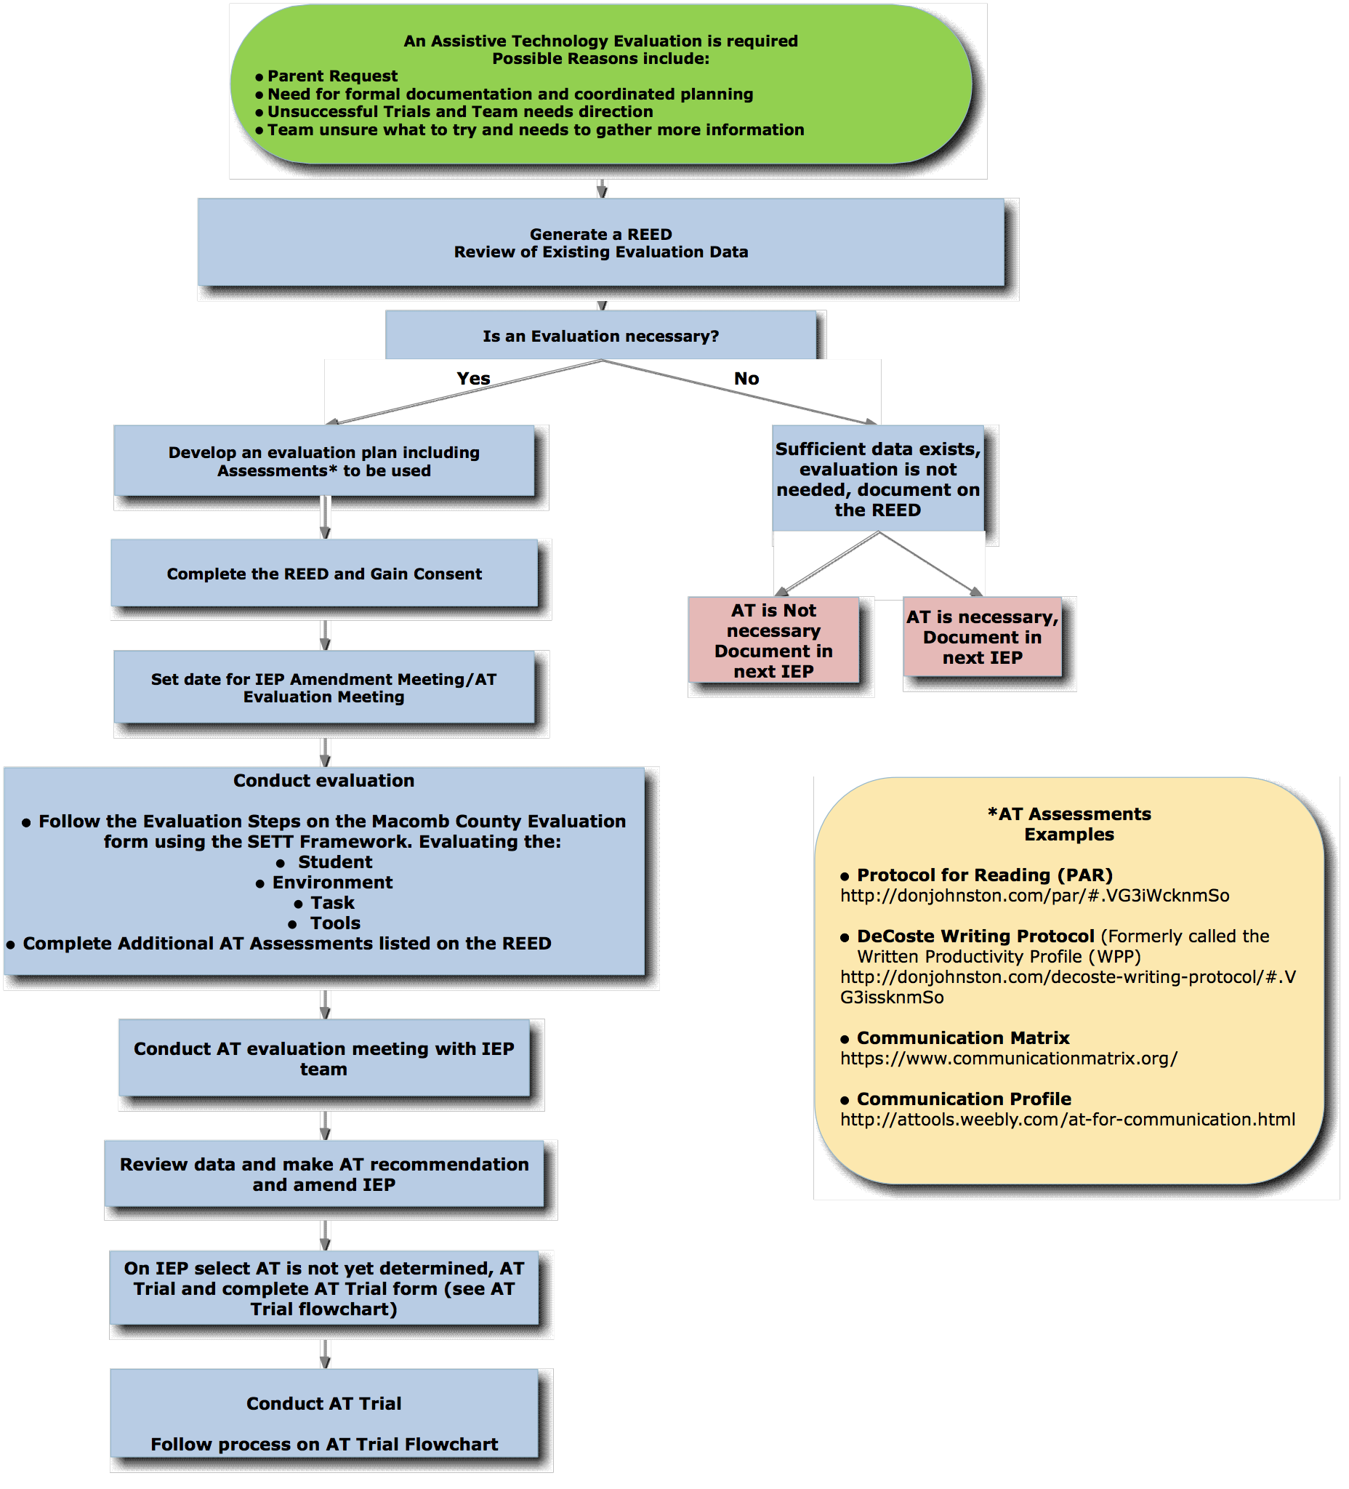

AT Consideration

Considering all special education students’ AT needs

As mandated by the Individuals with Disabilities Education Act 2004, Individual Educational Program (IEP) teams must consider the student’s need for assistive technology devices and services annually. Consideration is defined in the Merriam-Webster dictionary as “continuous and careful thought: a matter weighed or taken into account when formulating an opinion or plan.” IEP teams are required to document the outcomes of this “careful thought” in the student’s IEP. In Macomb County assistive technology consideration must always be addressed in the Consideration of Special Factors section of the IEP.

Some general rules about AT Consideration include:

* Because the student’s annual goals and objectives will be the focus of the discussion about assistive technology, AT consideration should occur later in the IEP process after these components of the educational plan have been developed.
* In order to think carefully about the whether to include AT devices and services into a student’s program, at least one person on the IEP Team must have adequate knowledge about assistive technology.
* Consideration should be a brief process, one that can take place within every IEP meeting without unduly extending it. It should last at least two minutes, but no more than 15 to 20 minutes. If a decision cannot be reached in a timely way, then AT needs may need to be addressed in another forum such as an assistive technology evaluation.

Quality AT Consideration means:

* Considering every student regardless of their disability
* Consideration comes from an informed decision making team
* Consideration is based on progress in the general curriculum
* Consideration occurs using data-based decisions
* Consideration is documented in the IEP

In order for IEP teams to adequately consider whether assistive technology supports are necessary at this time, the following set of guided questions should addressed annually.

1. What tasks related to the student’s IEP goals and objectives is the student unable to do at a level that reflects his/her skills/abilities? List the tasks.
2. Can these tasks be remediated through intense, direct instruction? The team should list instructional programs that may benefit the learner.
3. Could the student complete these tasks with new strategies or accommodations? The team should list the strategies and accommodations that may meet the student’s needs.
4. Would the use of assistive technology tools help the student perform the task more easily, efficiently, effectively or independently in the least restrictive environment? The team should list the assistive technology tools that may meet the student’s needs.

The process should include a generation of potential solutions, including assistive technology, if the student’s needs are not being met. The decision made by the IEP team must be documented in the IEP. See below.

**AT Consideration Tool Guide**

**Written Production**

Students who have difficulty producing written communication with standard writing tools may benefit from assistive technology. Samples of tools to support written production are listed below.

* Pencil grip
* Raised line paper
* Slantboard
* Audio recorder (recording pen)
* Portable word processor
* Netbook with word processor
* Computer with word processor
* Computer with word processor and abbreviation expansion
* Computer with word processor and word prediction
* Voice recognition software

**Written Composition**

Students who have difficulty composing written material may benefit from assistive technology. Samples of tools to support written composition are listed below.

* Word cards/word book
* Writing template
* Graphic organization software
* Graphic organization software with genre writing scaffolds
* Talking work processors
* Template writing software

**Reading**

Students who demonstrate difficulty with basic reading skills or reading comprehension skills may benefit from assistive technology. Samples of tools to support reading are listed below.

* Repeated line books
* Enlarged print, spacing, background change
* Reading window
* Page fluffers
* Pictures/symbols to support text
* Talking electronic word device - speak/define challenging words
* Recorded books - (AnyBook, Bookworm, Step-by-step)
* Audio books
* Hand held scanner
* Electronic book/textbook with reading software
* Reading software for web

**Spelling**

Students who demonstrate difficulty spelling, may benefit from assistive technology to identify and correct spelling errors. Samples of tools to support spelling are listed below.

* Talking dictionary/spell checker
* Word processing with spelling software
* Talking word processor with spelling support
* Word prediction software
* Voice dictation software

**Math**

Students who demonstrate difficulty with basic math skills may benefit from assistive technology. Samples of tools to support math are listed below.

* Math grid
* Money calculator
* Talking calculator
* Talking watch
* Calculator with print out
* Large display calculator
* Virtual manipulatives
* On screen graphing calculator
* Software for math computation (Math Pad)
* Voice recognition software

**Organization/Study**

Students who demonstrate difficulty with completing tasks, turning in assignments in a timely manner or staying organized may benefit from assistive technology. Samples of tools to support organization/studying are listed below.

* Picture schedule
* Highlight tape, tabs, flags
* Visual timer
* Digital voice recorder to set reminders for tasks/assignments
* Electronic organizer (handheld)
* Hand held scanner
* Recording pen
* Software for organizing ideas
* Handheld personal computer and picture cuing system
* Cloud-based organizational tools and handheld personal computer (e.g. Evernote and iPod Touch)
* Handheld personal computer and cuing system

**Communication**

Students with expressive communication impairments have benefit from assistive technology to supplement their communication skills. Samples of tools to support communication are listed below.

* Communication board with pictures/symbols/words
* Eye gaze board
* Simple voice output
* Voice output with levels
* Voice output with dynamic display
* Device with speech synthesis for text display

**Computer Access**

Students with physical or sensory impairments may benefit from assistive technology used to provide better access to the computer. Samples of tools to support written production are listed below.

* Built in operating system accessibility features (e.g. sticky keys, large cursor, zoom text, etc.)
* Word prediction/abbreviation expansion software
* Keyguard
* Zoom caps
* Arm support
* Alternate mouse ( e.g.track ball, track pad, joystick, touch screen, mouse emulator, head mouse)
* Alternate keyboard (e.g. one handed, enlarged key, small keyboard, on screen)
* Switch scanning
* Voice recognition software

**Vision**

Students with a visual impairment may benefit from assistive technology to access print, produce written communication, access the computer and navigate their environment. Samples of Vision Aids are listed below.

* Print magnifier
* Large print
* Auditory materials
* Closed circuit television (CCTV)
* Screen magnifier over monitor
* Screen magnifier software
* Screen reader
* Braille note taker
* Braille embosser
* Braille label for keyboards
* Refreshable Braille note taker
* Raised line picture embosser

**Hearing**

Students with a hearing impairment may benefit from assistive technology to access spoken words and environmental sounds. Samples of tools to support the hearing impaired are listed below.

* TDD for phone access
* Visual signaling device (for a phone, alarms etc)
* Closed captioning
* Real time captioning
* Computer aided note taking
* phone amplifier
* FM system
* Infrared system

Adapted from the Wisconsin Assistive Technology Assessment Package