Macomb Intermediate School District
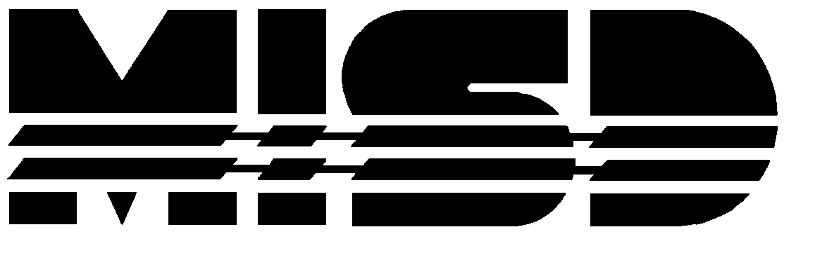
Rockwell Middle School • 12225 Masonic • Warren, MI • 48093 • 586/939-2290

Rockwell Middle School
Annual Education Report (AER) Cover Letter

January 28, 2026

Dear Parents and Community Members:

We are pleased to present you with the Annual Education Report (AER), which provides key information on the 2024-25 educational progress for Rockwell Middle School. The AER addresses the complex reporting information required by federal and state laws. The school’s report contains information about accountability, student assessment, and teacher quality. If you have any questions about the AER, please contact Corey Velazquez for assistance. (586-939-2290)

The AER is available for you to review electronically by visiting the following website: https://bit.ly/4jAcLil, or you may review a copy in the main office of your child’s school.

For the 2025-26 school year, schools were identified based on previous years’ performance using definitions and labels as required in the Every Student Succeeds Act (ESSA). A Targeted Support and Improvement (TSI) school is one that had at least one underperforming student group in 2024-25. An Additional Targeted Support (ATS) school is one that had at least one student group performing at the same level as the lowest 5% of all schools in the state in 2021-22. A Comprehensive Support and Improvement (CSI) school is one whose performance was in the lowest 5% of all schools in the state, had a graduation rate at or below 67%, failed to exit CSI status in 2024-25, or failed to exit ATS status in 2021-22. Some schools are not identified with any of these labels. In these cases, no status label is given.

Our school has not been given one of those labels. As reflected in the Annual Education Report, students at Rockwell present a variety of learning styles and academic abilities. While many students have Emotional Impairments, others have Cognitive Impairments, Autism Spectrum Disorder, and other disabilities that can make learning challenging.

To meet the individual needs of our students, instructional strategies are utilized across all academic areas. Rockwell continues to focus on school improvement goals, content specific professional development activities, enhancements for social emotional learning, and the use of assessment tools. These include, NWEA, MSTEP, MI-Access, and grade level pre and post testing on the identified power standards. Teachers also use informal classroom-based assessments to monitor student growth. We have implemented surveys for parents, students, and staff in the use of our Social-Emotional curriculum, True Success. This will help us better serve our population of diverse learners.

We have a district-wide social-emotional goal as part of our District School Improvement Plan. Ongoing professional development in the core content areas is focused on incorporating the educational support necessary to improve student learning and an opportunity for academic success. Students benefit from individualized instruction and direct modeling of desired behaviors. Intensive practice in social skills training, including Restorative Practices, assists students in reaching their potential in a supportive environment. Students also benefit from Positive Behavioral Interventions and Supports (PBIS) building wide. Training for students in the PBIS takes place on an ongoing basis and focuses on The Three R’s: (Responsibly, Respect, and Ready).

State law requires that we also report additional information.

Process for Assigning Pupils to School:
Rockwell Middle School provides educational services for students in 6th through 8th grade who are referred to our program from one of the 21 local school districts in Macomb County. Students who have an IEP in their resident district and/or demonstrate the need for a more structured, individualized program to meet their educational/emotional needs are referred to Rockwell Middle School. Once referred, the building administrator and/or designee observe the referred student at his or her local school. Following that, a student study team meeting occurs in which the referring team and Rockwell staff brainstorm strategies and ideas to help the student be successful in their LRE. Based on the study team meeting, an IEP to consider placement is scheduled, or an action plan is developed in which the Rockwell team provides support to the local district team in meeting the students’ unique needs.

Status of School Improvement Plan
We continue the following district-wide School Improvement goal:

Students in the Rockwell program demonstrate the need for direct specialized instruction in social emotional learning. We implement a PBIS program to increase student positive behavior outcomes and social emotional learning.

Strategies to increase student achievement in social emotional learning include:
- True Success training for teachers and students, with ongoing implementation school wide. Teachers collaborate frequently to share lessons and ideas.
- Frequent development and review of Functional Behavior Assessments, Positive Behavior Support Plans and Emergency Intervention Plans, with parent input.
- Consistent and frequent implementation of building-wide PBIS to serve as a motivator to students. Students are surveyed frequently to inventory areas of interest.
- SWIS (behavioral) data is reviewed bi-weekly at classroom team meetings; trends are used to improve upon and enhance the building-wide PBIS.
- Enhanced PBIS initiatives, such as the eSports Club, Friday incentives and monthly field trips.
- Partnerships with community agencies to support positive behaviors, such as drama club (All the Worlds a Stage), and therapy dogs (Fur Angels).
- Integration Room for students who are currently integrated or are preparing to reach that goal.
- Daily restorative circles that focus on feelings, sharing, problem solving and celebrating.
- School social worker pushes into classrooms to provide activities and support.
- “Hands on Monday” classes where Monday afternoons are dedicated exclusively to hands-on learning. Students can select their interest areas from many options that include science, cooking, art, jewelry making, community service, computers, crafts, music, leisure sports.

Ongoing strategies to increase student achievement in core academic areas, to support past School Improvement Goals, include:
- Data collection and analysis using NWEA, daily target tracking sheets, cumulative pre-mid-post testing on identified power standards as well as formative and summative assessments on individual standards. Full staff data shares to celebrate student and staff success takes place at the end of Semester 1 and Semester 2.
- Motivators for completing academic tasks are provided and staff work with students to discover what their individual motivators are.
- Professional development in the areas of Reading, Writing, English Language Arts, and Mathematics for teachers, paraprofessionals and ancillary staff members.
- Teachers participate in grade level PLC meetings each Friday where data is reviewed, curriculum pacing guides are reviewed and collaboratively share strategies for success.
- Response to Intervention groups run by classroom teacher as well as paraprofessionals for students struggling in English/ Language Arts or Math.
- An increase in technology to support learning, including Microsoft 365 and classroom smart boards, with ongoing training for Rockwell stakeholders.
- Rockwell has developed a 3-D printing program to enhance students’ knowledge of technology in a way that they enjoy.
- Mentoring and support for new teachers, including frequent one-on-one sessions with administration, frequent observations, and recommendations for success.

Description of Our School/Program
Rockwell provides an academic and behavioral program for middle school students with severe emotional impairments or significant behavioral challenges residing in Macomb County. As of January 2026, we have 73 students enrolled. Our overall average daily attendance is 86%.

Access a Copy of Core Curriculum
At Rockwell we utilize the Michigan Department of Education Academic Standards which can be viewed at: https://www.michigan.gov/mde/services/academic-standards

Student Achievement Results for any Local Competency Tests
Students at Rockwell take the NWEA assessment in the areas of Reading, Language and Mathematics three times per year: in the fall, in the winter and in the spring. Results are analyzed regularly to ensure students are progressing throughout the year. Based on analysis of existing data, students continue to show specified growth across Reading, Language and Mathematics. Teachers meet frequently to analyze NWEA results. However, instructional strategies are developed and implemented building-wide at frequent Professional Development and PLC sessions.

Data is collected and analyzed in academic areas based on Easy CBM (average percentage), Fountas and Pinnell (percentage of students reading at grade level) and SRSD writing (average percentage on the rubric). Those results are listed below.

2024-25 Rockwell Fall NWEA Assessment Results
Grade | Math | Reading | Language
6th | 194 | 194 | 190
7th | 187 | 192 | 197
8th | 189 | 191 | 181

2024-25 Rockwell Spring NWEA Assessment Results
Grade | Math | Reading | Language
6th | 195 | 194 | 193
7th | 192 | 193 | 199
8th | 198 | 199 | 189

Data should be interpreted with caution. Many students are referred to Rockwell as the school year progresses, and some students may have missed instruction due to absences and/or behaviors at their local district, which can contribute to lower achievement scores. The Rockwell team works diligently to remediate any academic content that was previously missed.

Parent Participation at Conferences and IEPs:
Parent attendance at Parent-Teacher Conferences during 2024-2025 was 98% based on in-person, phone and Zoom participation. Our IEPs were also well-attended; some were held via Zoom, reaching our attendance and participation level to 99%.

In addition to parent conferences and IEPs, Rockwell hosted an Open House at the beginning of the school year. This provided our staff an opportunity to welcome Rockwell families and the opportunity to meet with Rockwell staff and share available resources. Throughout the course of the year, Rockwell also provides many families with pantry items, clothing items, winter weather attire as well as holiday meals and gifts.

From the Principal:
Our Rockwell mission is to educate a diverse population of students in a safe and positive learning environment. Administrators, teachers, parents and students work together as partners in learning to actively engage, motivate and provide the skills necessary to become lifelong learners, as well as positive contributing members of the community. Rockwell Middle School is dedicated to creating a nurturing, supportive, and safe environment where all students can learn and be successful. Families and community involvement are crucial to this process.

Please contact the school if you have any questions regarding this report.

Sincerely,

Corey Velazquez
Principal

